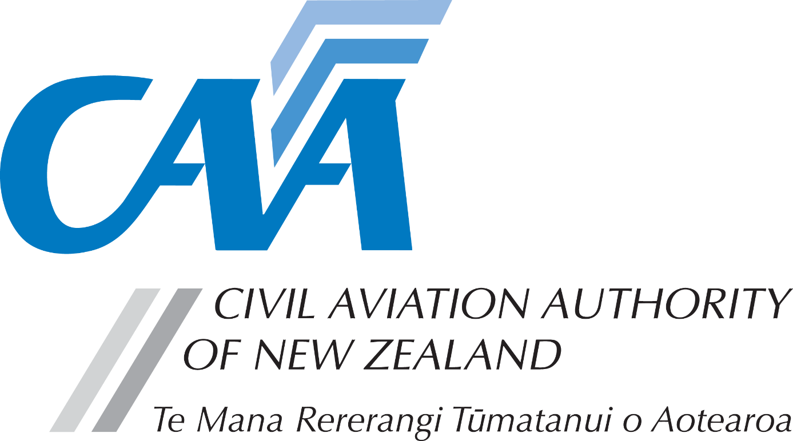
Recognition of Foreign AME Licence

Notes to applicants:
- A completed Fit and Proper Person Questionnaire, form CAA 24FPP or CAA 24FPPDEC, is required with this application. Refer to the 24FPP form for guidance on the appropriate form to be used.
- Personal details
CAA participant number (if known) |  |  |  |  |  |  | Date of birth dd/mm/yy)
Title (Mr/Mrs/Ms/Miss) |  |  |  | Last name
Given name(s)
Country of birth |  |  |  |  |  | Nationality
Address for service - Civil Aviation Act, s8, requires applicants to provide an address for service in New Zealand (i.e. a physical address) and to promptly notify the Director of any changes.

Phone |  |  |  | Mobile
Email
Postal address (if different from address for service)
Phone |  |  |  | Mobile
Email
- Recognition requirements
The CAA will only recognise a current and valid foreign AME Licence issued by an ICAO contracting state, as the basis for issue of a New Zealand Civil Aviation Rule Part 66 Aircraft Maintenance Engineer Licence (AMEL).
This is on the following provisos:
- CAA has confidence in, and understands the ICAO state's AMEL system, including meeting ICAO Annex 1 requirements.
- The ICAO issuing state verifies with CAA the authenticity and validity of the AMEL.
- (UK CAA AML holders need to apply directly to UK CAA on their form SRG1160 for permission of this verification check)
- As part of the application you must have an “address for service” in New Zealand.
- As a minimum, applicants will be required to pass Air Law Written and Oral, and Human Factors examinations. Other examinations may be required depending on your foreign licence requirements.
- (CASA AMEL holders only required to pass Air Law Written).
- Ratings are only issued for aircraft types on the New Zealand Register
Note the following:
- The FAA A&P Certificate, or other ICAO state Certificates based on the FAA Certificate are not recognised.
- EASA/JAA Category A licences are not recognised
- Examination credits without a licence are not recognised.
The CAA does not offer an individual assessment service prior to application. The CAA contracts ASPEQ to assess foreign AMELs. ASPEQ offers a pre-application assessment service for a fee. This is not mandatory but will advise which ratings are recognised and which examinations are required. Contact ASPEQ direct for details. https://caanz.aspeqexams.com/home
For further information, refer to the CAA website - www.aviation.govt.nz and follow through the Licensing & Certification pages to Recognising foreign AME licences. For additional information refer to AC66-1.
- Details of foreign licence
Please complete details relating to your foreign licence(s). | Foreign licence number | Country or state | Expiry date | Date first issued
A certified copy of your licence, relevant course certificates, experience logs and authorisations held to be included with this application.
- Fees & payment details
- Please pay online at https://sec.caa.govt.nz/onlinepayment and attach the receipt that will be emailed to you.
- Unless the full fees are paid and receipt is attached, applications will not be processed.
- For information relating to fees, refer to the Civil Aviation Charges Regulations.
Payment details
Total fees
Receipt number
- Declaration
The provision of false information or failure to disclose information relevant to the grant or holding of an aviation document constitutes an offence under Section 49 of the Civil Aviation Act 1990 and is subject, in the case of an individual, to imprisonment for a term not exceeding 12 months or to a fine not exceeding $10,000. | I declare that to the best of my knowledge and belief the statements made and the information supplied in this application and the attachments are complete and correct.  Consent to disclosure & collection  I authorise the collection by the Director of Civil Aviation or his delegate (hereinafter referred to as "the Director") from, and the disclosure to the Director by, any person, organisation or government department of any details of my knowledge & compliance with transport safety regulatory requirements.  I authorise the Director to use, and disclose, the information obtained about me for any purpose under the Civil Aviation Act 1990.
 | Applicant’s signature |  | Date
- Applicant’s checklist
Please ensure all documents are enclosed.  Applications which are incomplete or lacking any required documents will be returned. | - Fit and proper person questionnaire – either 24FPP or 24FPPDEC | ☐
 | - Certified copies of relevant course certificates, experience logs and authorisations held | ☐
 | - Certified copy of Foreign Licence | ☐
 | - Payment receipt | ☐

Submit the completed application to either:
Email: lic.applications@caa.govt.nz
Post: Civil Aviation Authority, PO Box 3555, Wellington 6140, New Zealand

