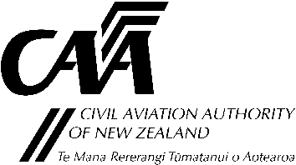
Aircraft Radio Station Equipment Approval Levels

Application requirements and instructions for completing the form
- Guidance for completing this form is in Advisory Circular AC43-10.
- Submit the completed form to either:
Email: certification@caa.govt.nz
Post: Certification Unit, Civil Aviation Authority, PO Box 3555, Wellington 6140

1. Aircraft Description
Aircraft Model: |  | Registration: ZK-

2. Radio Equipment List
Item No. | Function | No. | Make/Model | Level | MOD REF
Note: The column headed ‘MOD REF’ should be completed by quoting the appropriate modification approval or service bulletin number for equipment fitted since the last CAA2129. For all other equipment, enter “I” for Installed.

3. Certification
Form completed by: |  |  |  |  | Date:
Signature: |  |  | Licence/Approval/Authorisation No.
Reason: (select as applicable) | ☐ Incorporation of modification(s) |  |  | ☐ initial issue
 | Other:
4: Types of Operations
The scale of radio and navigation equipment required for various types of flight operations is prescribed in Civil Aviation Rules, Parts 91, 121 and 135.
The minimum level of approval for the equipment detailed in Section 2 must be:
- For IFR operations — All required equipment must be Level 1
- For VFR operations — All required equipment must be Level 1 or 2
Conditions:

